Adult stem cell therapies can ease pain, avoid surgery
Posted: Thursday, May 7, 2015 12:00 pm DR. REUBEN GOBEZIE Special to the CJN

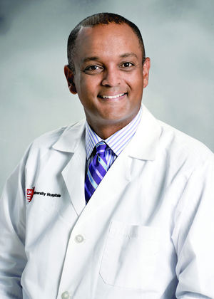Dr. Reuben Gobezie
Arlene Abrams had been dealing with pain in both of her shoulders for more than a decade. Though she had surgery on her right shoulder for a rotator cuff tear, a few years later, she began to experience significant pain and limited range of motion once again.
“MRI scans of both shoulders showed extensive tearing, retractions and damage,” Arlene said. “My only surgical option would be total shoulder replacements.” But Arlene wanted to avoid another shoulder surgery as long as possible. A new therapy involving the use of her adult stem cells has so far helped her dodge the operating table.
Arlene opted to try a regenerative medicine treatment, sometimes referred to as biologics. This is a cutting-edge new treatment that replaces injured tissues with new, functioning tissues – regenerated from an individual’s own adult stem cells. Through the therapy, stem cells stimulate previously damaged tissue to regain structure and recover. As her body responded and healed, Arlene’s pain subsided and her range of motion increased.
“A few weeks from having the procedure, I noticed that holding my wiggly four-month-old granddaughter did not stress my shoulders,” Arlene said. “I no longer have pain picking up a gallon of milk or laundry soap. I could not be more pleased.”
Regenerative medicine uses an individual’s adult stem cells and blood platelets to stimulate healing and speed repair for bone, muscle, joint, soft tissue and nerve injuries. We all carry stem cells that act as a “repairmen.” Healthy regenerative cells are present within fat tissues, bone marrow and adipose connective tissue. This biologic treatment takes the healthy, regenerative cells from an area that is rich with them, and injects them into an injured area of the body that is in need of them.
Since the cells are collected from a patient’s tissue, they do not pose a threat for rejection when transplanted to the injured site. Using ultrasound guidance for precise placement, a physician injects the cells into the injured tendon, ligament, nerve, muscle, bone or joint. The procedure does not require a hospital stay.
“I had the stem cell treatment right there in the doctor’s office,” Arlene said. “I first began to notice improvement with both the chronic pain and limited range of motion about two weeks post procedure, and things have continued to significantly improve.”
As more and more patients are looking for ways to avoid ongoing steroid treatments or surgery, regenerative medicine can be an alternative.
Regenerative medicine can help a number of conditions including, including osteoarthritis, meniscus tears, rotator cuff injuries, muscle strains, tennis elbow, Achilles tendinitis, other forms of tendinitis or tendinosis, ligament sprains, plantar fasciitis, compression nerve injuries and nonunion fractures.
Dr. Reuben Gobezie is an orthopedic surgeon and founder/director of the Cleveland Shoulder Institute and Regen Orthopedics at University Hospitals Ahuja Medical Center in Beachwood.
Content provided by our advertising partner

